**Asset Eater – Installation Instructions**

Open Chrome and go to **chrome://extensions/**

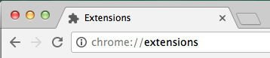

**Or** click the icon with three dots in the top right of the window and go to **More Tools > Extensions**

Navigate to the following directory:

file://localhost/Volumes/Sky Works Storage/Sky_Works_Share/Luke_Twomey/

Drag the **Asset Eater.crx** file anywhere onto the Chrome extensions screen and drop to install:

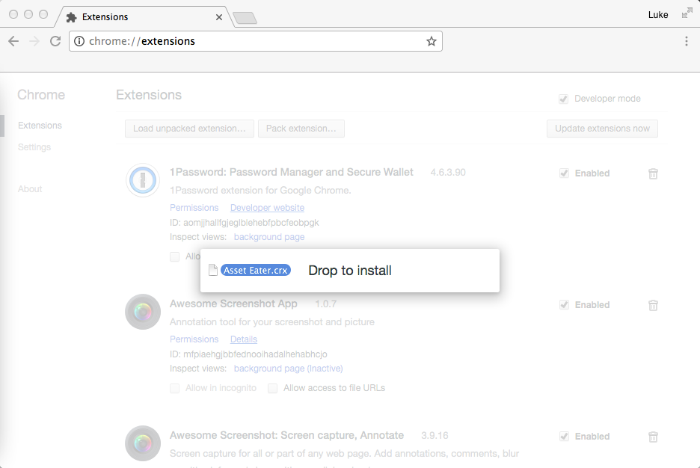

Click the **Add Extension** button when prompted to install the extension:

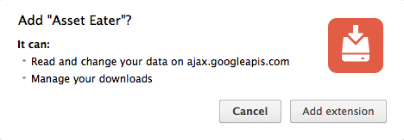

The extension should now be installed and available to use, to the right of the URL bar:

